Comcast Telecom Consumer Complaints
Project Report

Aparna Nair
aparna.nair.vijay@gmail.com
Business Scenario
Comcast is an American global telecommunication company. The firm has been providing terrible customer service. They continue to fall short despite repeated promises to improve. Only last month (October 2016) the authority fined them a $2.3 million, after receiving over 1000 consumer complaints.
The existing database will serve as a repository of public customer complaints filed against Comcast.
It will help to pin down what is wrong with Comcast's customer service.

Objectives
Analysis Task
- Import data into Python environment.
- Provide the trend chart for the number of complaints at monthly and daily granularity levels.
- Provide a table with the frequency of complaint types.

- Which complaint types are maximum i.e., around internet, network issues, or across any other domains.

- Create a new categorical variable with value as Open and Closed. Open & Pending is to be categorized as Open and Closed & Solved is to be categorized as Closed.

- Provide state wise status of complaints in a stacked bar chart. Use the categorized variable from Q3. Provide insights on:
Which state has the maximum complaints
Which state has the highest percentage of unresolved complaints

5.Provide the percentage of complaints resolved till date, which were received through the Internet and customer care calls.

DATASET DESCRIPTION
- Ticket #: Ticket number assigned to each complaint
- Customer Complaint: Description of complaint
- Date: Date of complaint
- Time: Time of complaint
- Received Via: Mode of communication of the complaint
- City: Customer city
- State: Customer state
- Zipcode: Customer zip
- Status: Status of complaint
- Filing on behalf of someone

Dataset has 2224 observations of 11 variables

Statistical algorithm execution – Python code and outputs
Objective 1) - Import data into Python environment.
- Provide the trend chart for the number of complaints at monthly and daily granularity levels.
- Provide a table with the frequency of complaint types.

#Importing the data set and analyzing the data
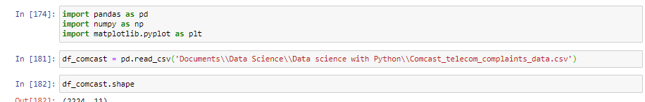

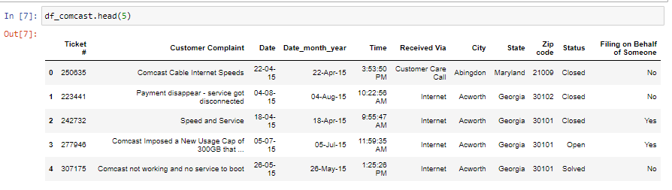

#importing datetime for conversion of Date fields in to datetime datatype
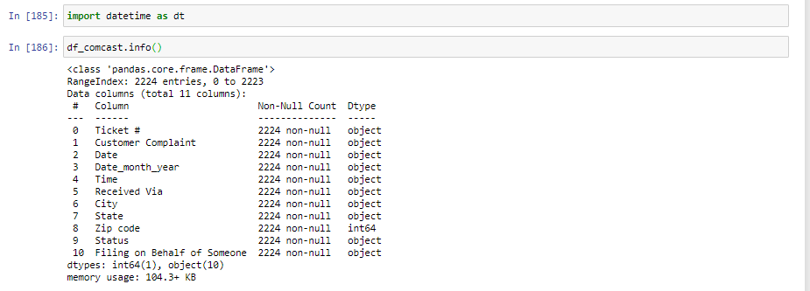
# Creating new field Datenew1
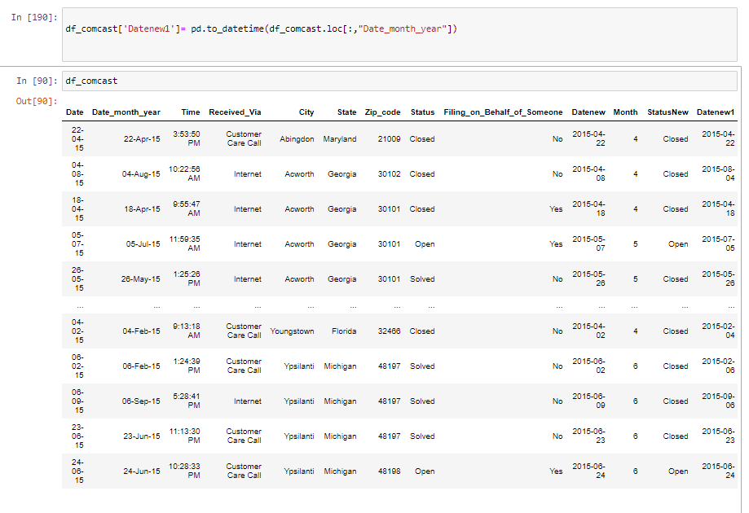
#Replacing the “ ” in column name with _
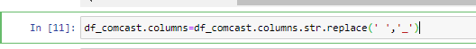
#Creating a new column Month
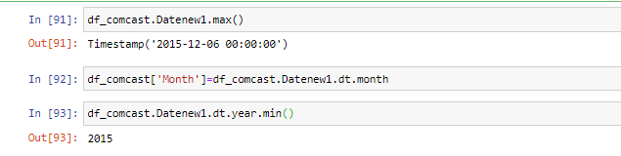
# Complaint count monthwise
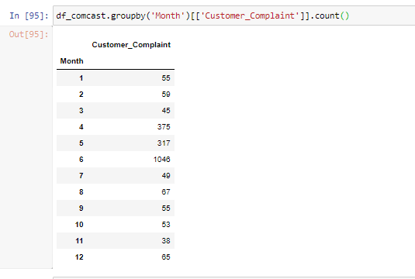
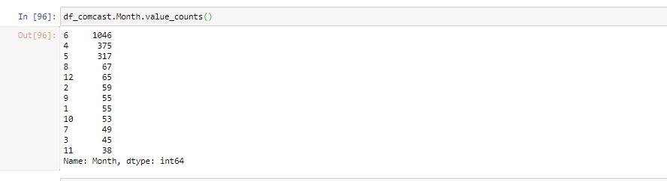

#Complaints reported in June is quite high compared to other months

Trend chart for monthly number of complaints
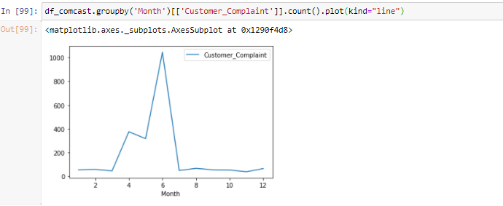

Trend chart for daily number of complaints

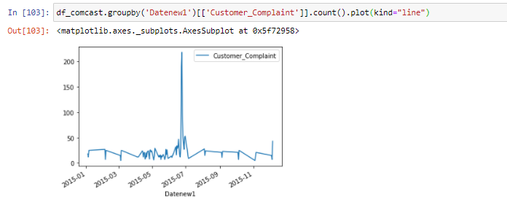

Provide a table with the frequency of complaint types.

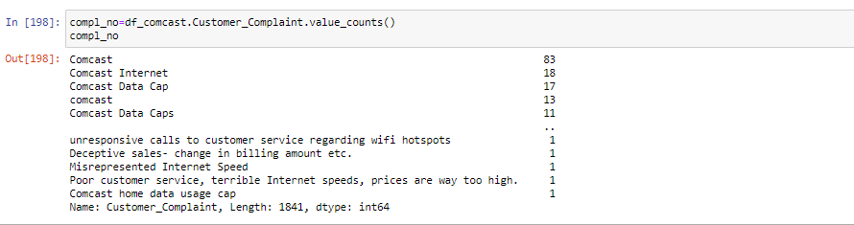

Objective 2)Which complaint types are maximum i.e., around internet, network issues, or across any other domains.

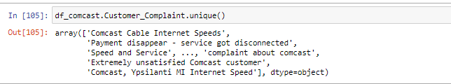
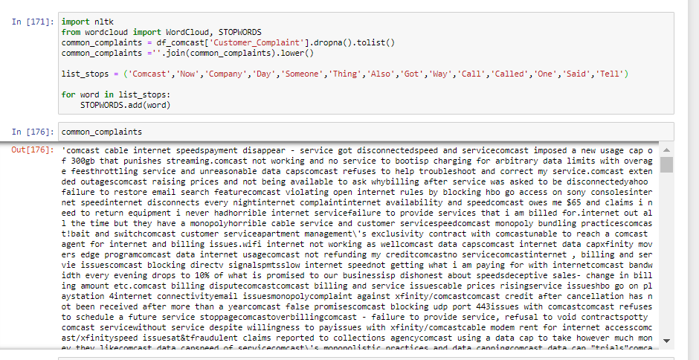
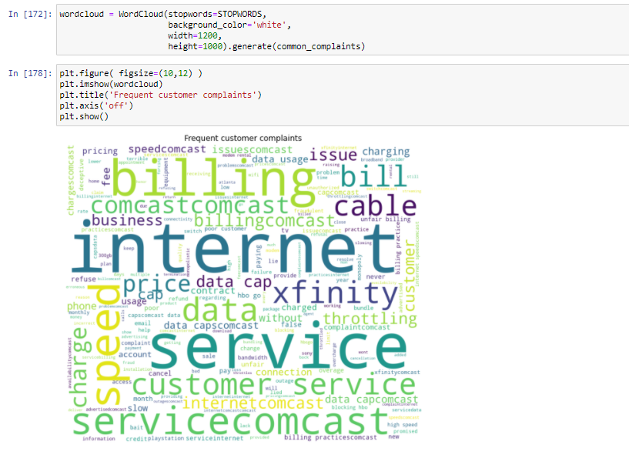
Maximum complaints are around Internet
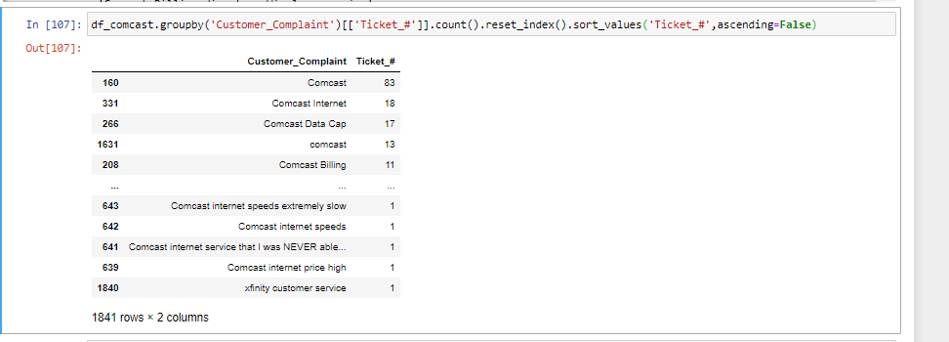
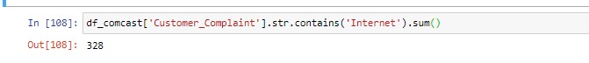
Objective 3)Create a new categorical variable with value as Open and Closed. Open & Pending is to be categorized as Open and Closed & Solved is to be categorized as Closed.

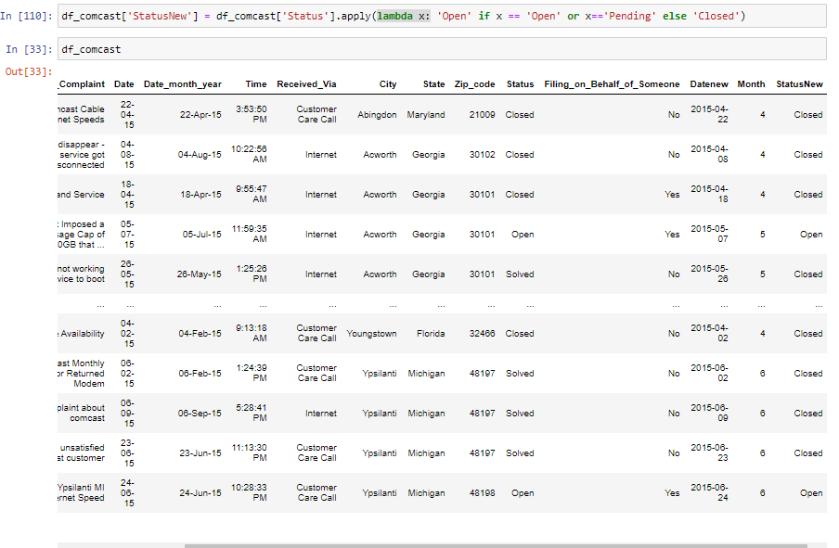
Created a new field Status New with Open and Closed status
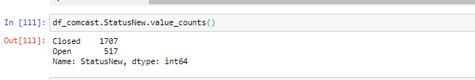

Objective 4)Provide state wise status of complaints in a stacked bar chart. Use the categorized variable from Q3. Provide insights on:
Which state has the maximum complaints
Which state has the highest percentage of unresolved complaints

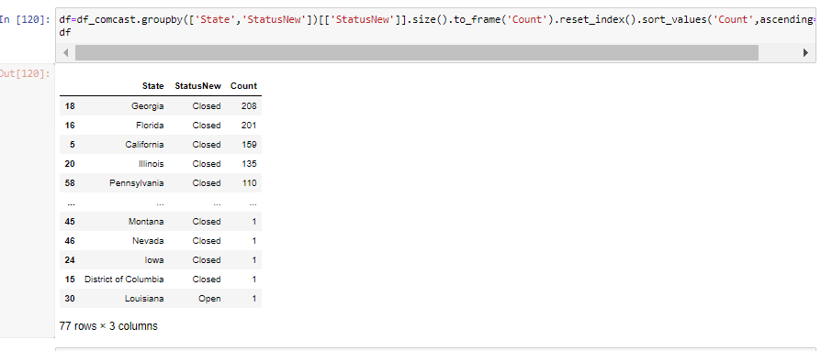

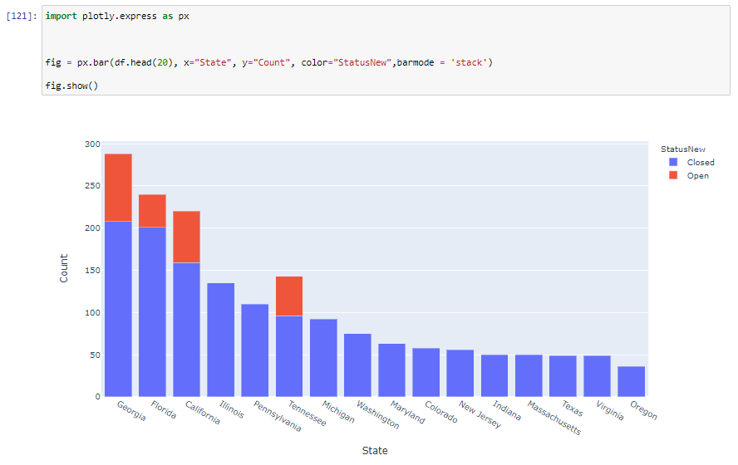
# Georgia has maximum complaints

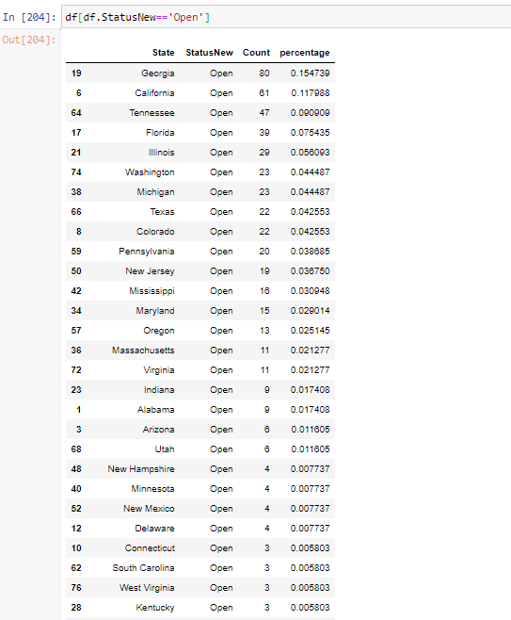
Georgia has high percentage of unresolved complaints (15.47%).
Objective 5)Provide the percentage of complaints resolved till date, which were received through the Internet and customer care calls.
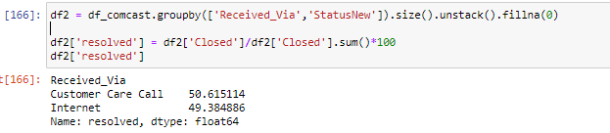

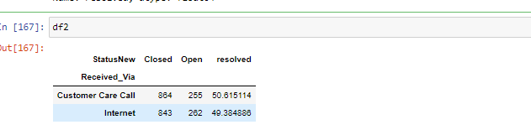
Percentage of complaints resolved till date, which were received through the Internet and customer care calls is 49.38% and 50.61% respectively

Result
Analysis Task

- Objective 1 - Import data into Python environment.
- Provide the trend chart for the number of complaints at monthly and daily granularity levels.
- Provide a table with the frequency of complaint types.

Dataset was imported and analysed
Trend chart for number of complaints at monthly and daily granularity levels visualized. It was observed that complaints reported in June is quite high compared to other months
Frequency of complaint types table analysed (Refer pages 4- 7)
- Objective 2 - Which complaint types are maximum i.e., around internet, network issues, or across any other domains.

Maximum complaints are around Internet (Refer pages 8-9)
- Objective 3 - Create a new categorical variable with value as Open and Closed. Open & Pending is to be categorized as Open and Closed & Solved is to be categorized as Closed.
Created a new field Status New with Open and Closed status (Refer pages 9-10)
- Objective 4- Provide state wise status of complaints in a stacked bar chart. Use the categorized variable from Q3. Provide insights on:
Which state has the maximum complaints
Which state has the highest percentage of unresolved complaints
Georgia has maximum complaints and highest percentage of unresolved complaints (Refer pages 11-12)
- Objective 5 - Provide the percentage of complaints resolved till date, which were received through the Internet and customer care calls
Percentage of complaints resolved till date, which were received through the Internet and customer care calls is 49.38% and 50.61% respectively ( Refer pages 13)

